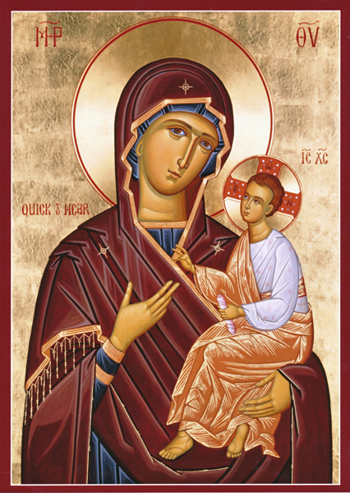

Prayers for making prosphoro

Trisagion prayers

In the name of the Father and the Son and the Holy Spirit. Amen

Glory to you our God, glory to you.

Heavenly King, Comforter, the Spirit of Truth, present everywhere and filling all things, the treasury of good and the giver of life, come and dwell in us and cleanse us from every impurity, and save our souls, Gracious One.

Holy God, Holy Mighty, Holy Immortal, have mercy on us. (3)

Glory to the Father and the Son and the Holy Spirit;

Both now and ever and to the ages of ages. Amen.

All-holy Trinity, have mercy on us.

Lord, be merciful to our sins.

Master, forgive our transgressions.

Holy One, visit us and heal our infirmities, for your name’s sake.

Lord have mercy, Lord have mercy, Lord have mercy.

Glory to the Father and the Son and the Holy Spirit

Both now and ever and to the ages of ages. Amen

Our Father in the heavens,

Hallowed be your name

Your kingdom come

Your will be done, on earth as it is in heaven.

Give us this day our daily bread

And forgive us our sins

As we forgive those who sin against us

And lead us not into temptation

But deliver us from the evil one.

For yours is the kingdom and the power and the glory of the Father and the Son and the Holy Spirit,

Now and ever and unto the ages of ages. Amen

BEFORE STARTING

I thank you Lord, for this holy moment where you have counted me worthy to knead with my sinful hands the all-immaculate Gifts of Your love.

I plead with You to send down your All Holy Spirit, Who blesses all the mysteries of the Church, to also bless these gifts so that they become good and acceptable before Your Holy Altar.

And I ask that you accept them as you accepted Abel’s sacrifice, the glorification of the shepherds, the gifts of the Magi, the tears of Peter and the thief’s repentance.

And make me worthy to always offer them to You with a good conscience. Amen.

AND

“Through the prayers of our holy fathers, Lord Jesus Christ, our God, have mercy on us. Amen. Glory to you, our God, glory to you.

O God, whose only-begotten Son has said, “Without Me you can do nothing” my Lord and my God, in faith I bend the knees of my soul before your Fatherly goodness and I raise my hands to you : help me, a sinner to do this work in conformity with your will.

Send down your Holy Spirit to guide me in making these prosphora, that they may be worthy of the use for which they are intended.

CLOSING PRAYER

O God, our God, You sent the heavenly Bread, the food for the whole world, our Lord and God Jesus Christ, as Saviour, Redeemer and Benefactor to bless us and sanctify us. Do bless this offering and accept it upon Your heavenly altar.

As a good and loving God, remember those who brought it and those for whom it was brought.

Keep us blameless in the celebration of Your divine Mysteries.

For sanctified and glorified is Your most honourable and majestic name, of the Father and the Son and the Holy Spirit. Amen.